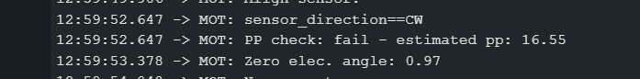

Parametrii motor2

